Project Development Phase
Model Performance Test

Date | 8 FEB 2026
Team ID | LTVIP2026TMIDS39173
Project Name | ToyCraft Tales: Tableau's vision into toy manufacturer data
Maximum Marks

Model Performance Testing:

S.No. | Parameter | Screenshot / Values
1. | Data Rendered | 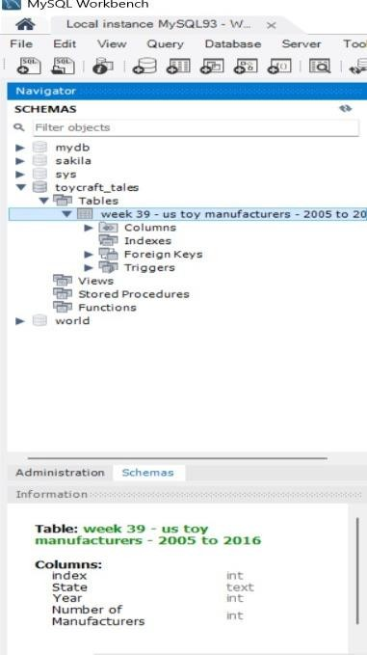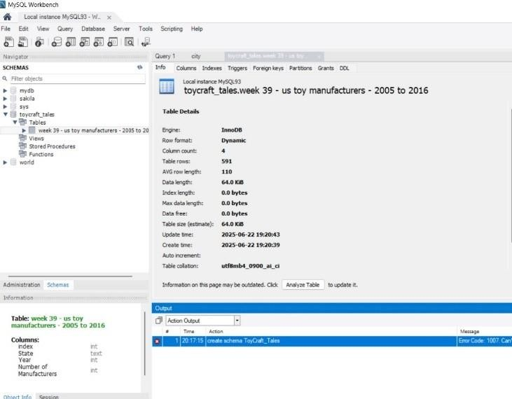

2. | Utilization of Filters | 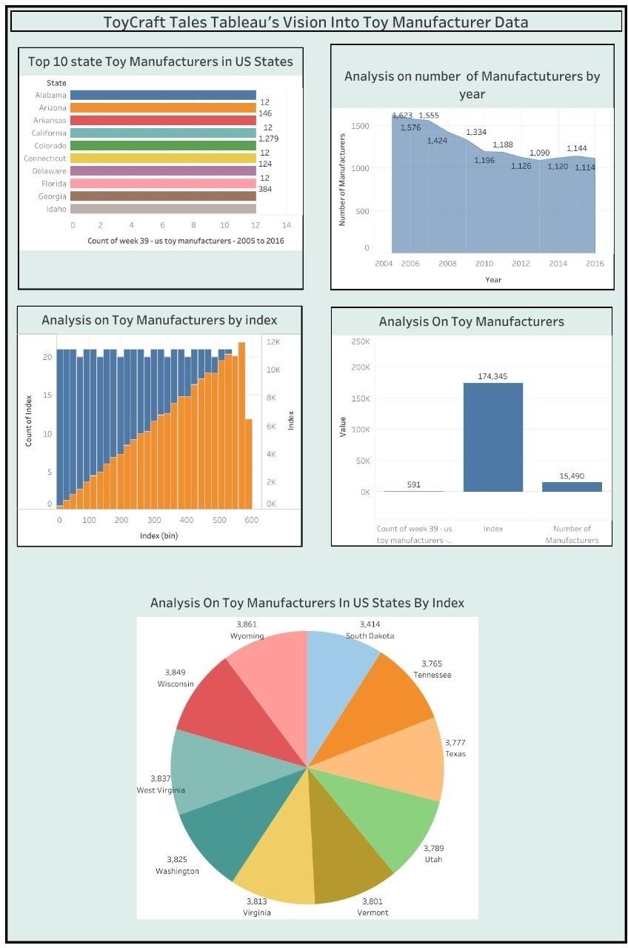

3. | Calculation fields Used | 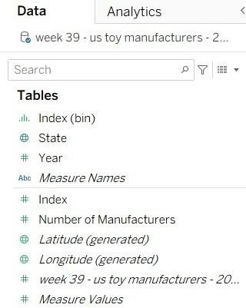
4. | Dashboard design | 
5. | Story Design | 